**PRACTICAL NO: 3**

**AIM: SOLVE THE FOLLOWING SIMPLE QUERIES AND USE APPROPRIATE AGGREGATE FUNCTIONS USE FYIT_40**

Q1. FIND THE DESCRIPTION AND QUANTITY ON HAND OF THE PRODUCT P2

SELECT DESCRIPTION,QTYONHAND FROM PRODUCT

WHERE PRODUCTNO='P2'

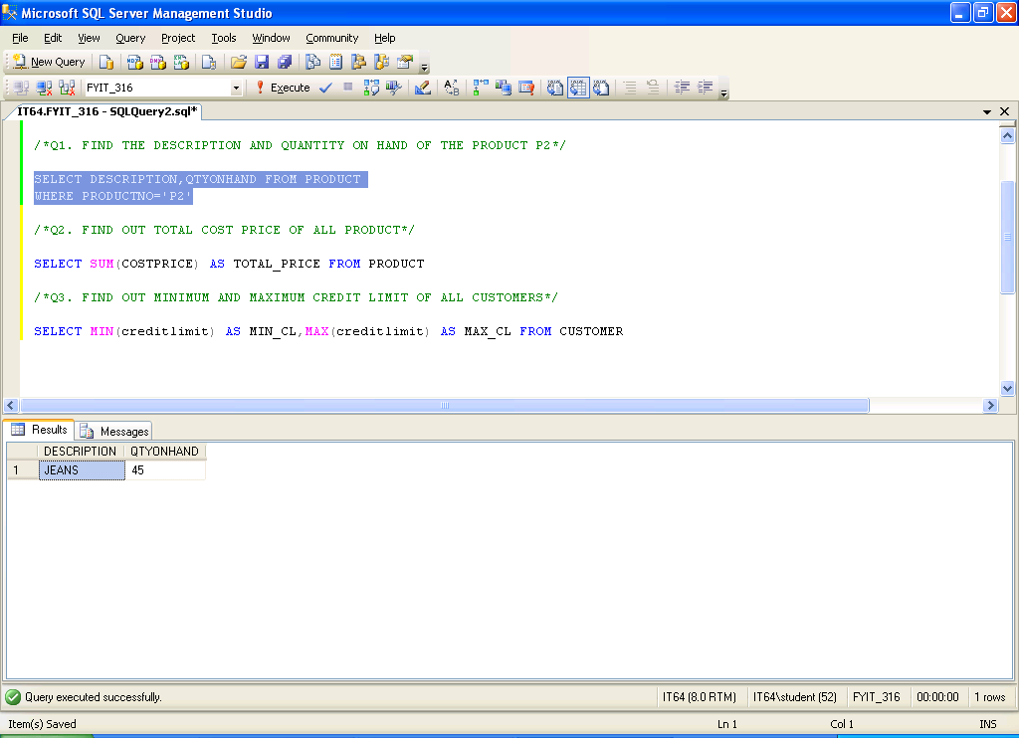

Q2. FIND OUT TOTAL COST PRICE OF ALL PRODUCT

SELECT SUM(COSTPRICE) AS TOTAL_PRICE FROM PRODUCT

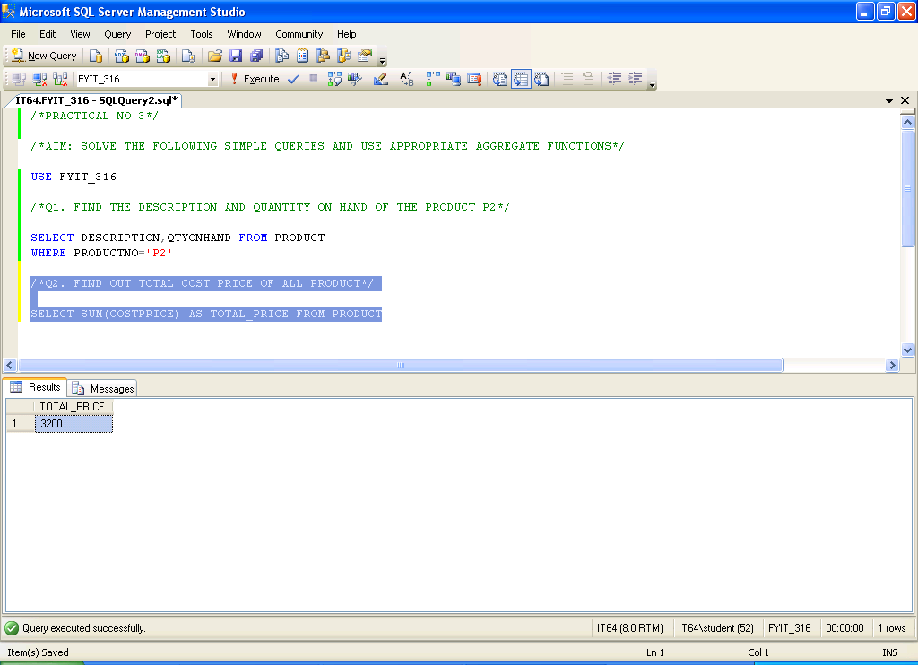

Q3. FIND OUT MINIMUM AND MAXIMUM CREDIT LIMIT OF ALL CUSTOMERS

SELECT MIN(creditlimit) AS MIN_CL,MAX(creditlimit) AS MAX_CL FROM CUSTOMER

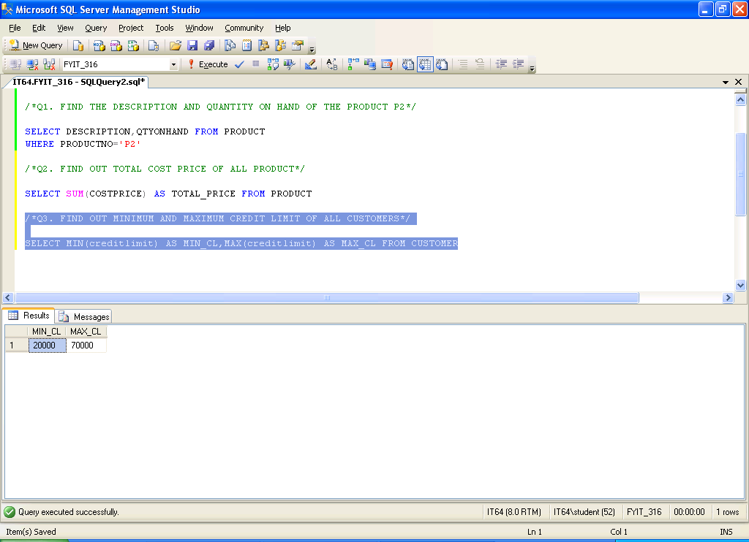

Q4. FIND OUT AVERAGE SALES AMOUNT OF ALL SALESMAN

SELECT AVG(SALESAMT) AS AVG_SALESAMT FROM SALESMASTER

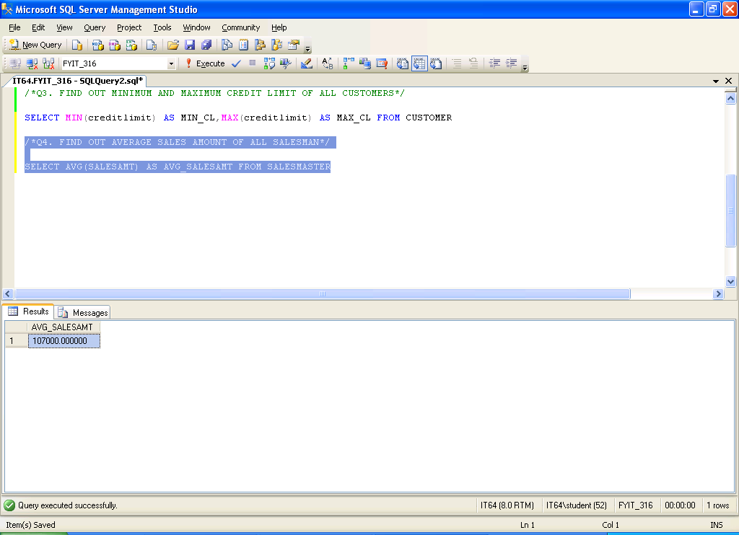

Q5. FIND OUT CUSTOMERS LIVING IN CITY DELHI AND MUMBAI

SELECT custno,cname FROM CUSTOMER

WHERE city IN('DEHLI','MUMBAI')

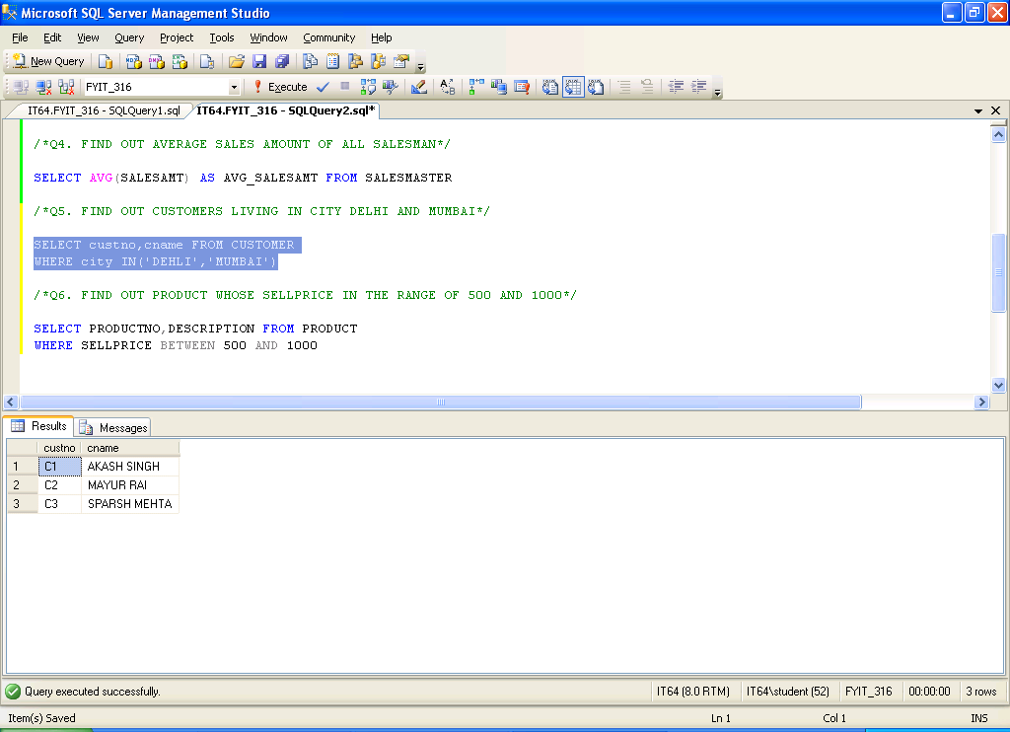

Q6. FIND OUT PRODUCT WHOSE SELLPRICE IN THE RANGE OF 500 AND 1000

SELECT PRODUCTNO,DESCRIPTION FROM PRODUCT

WHERE SELLPRICE BETWEEN 500 AND 1000

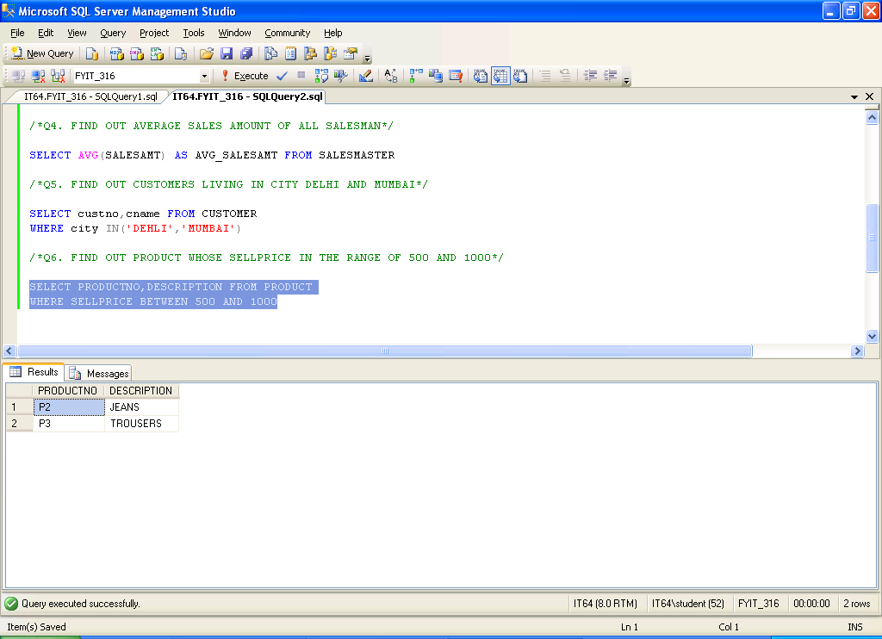

Q7. FIND OUT SALESMAN WHOSE NAME STARTS WITH 'A'

SELECT SALESMANNO,SNAME FROM SALESMASTER

WHERE SNAME LIKE 'A%'

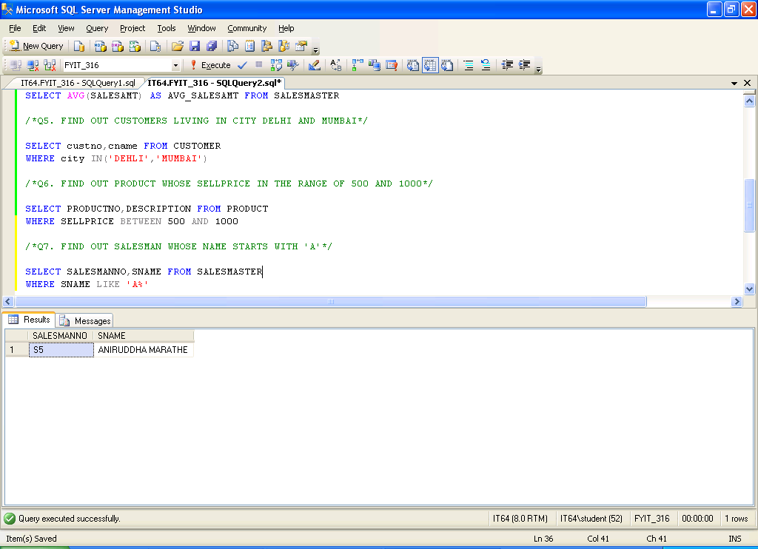

Q8. FIND OUT TOTAL NO OF CUSTOMER LIVING IN EACH CITY

SELECT COUNT(custno) AS NO_OF_CUSTOMER,city FROM CUSTOMER

GROUP BY city

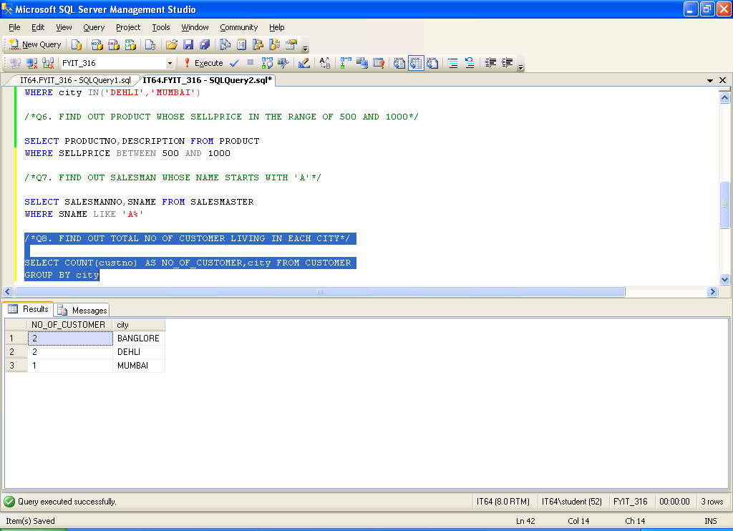

Q9. FIND OUT TOTAL ORDER FOR EACH ORDERSTATUS

SELECT COUNT(ORDERNO) AS NO_OF_ORDERS,ORDERSTATUS FROM SALESORDER

GROUP BY ORDERSTATUS

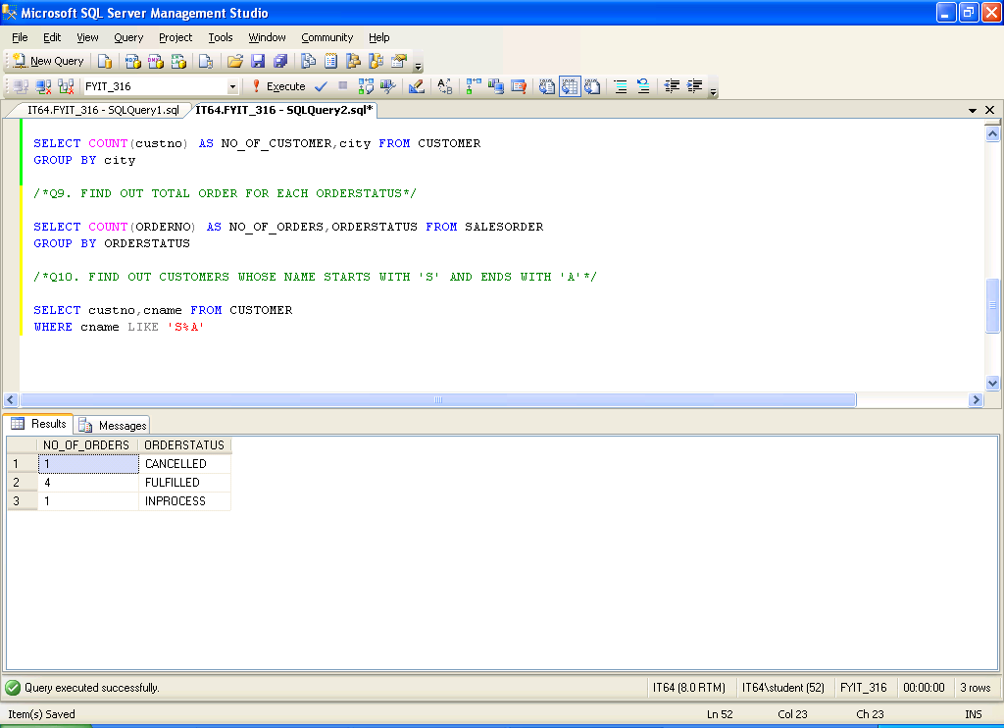

Q10. FIND OUT CUSTOMERS WHOSE NAME STARTS WITH 'S' AND ENDS WITH 'A'

SELECT custno,cname FROM CUSTOMER

WHERE cname LIKE 'S%A'

